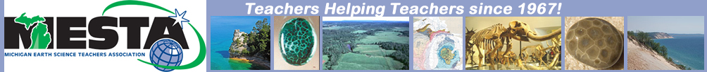Menominee Adventure Aug 2-5, 2021
Michigan Earth Science Teachers Association (MESTA) in cooperation with Wisconsin Society of Science Teachers (WSST)

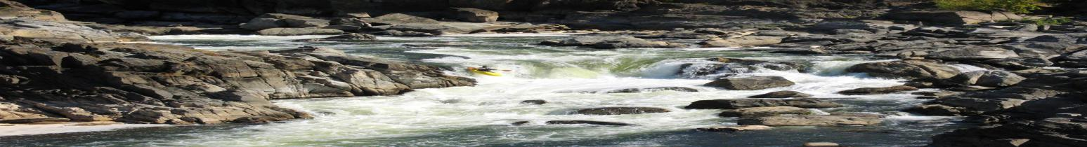

Registration Form

Name: _________________________________ email address* __________________________
phone (cell preferred)* _______________________________
Mailing address* _________________________ City, state zip* __________________________

(*We will send participants information about housing options, what to bring and other details.)

Registration includes: a couple of lunches, mine museum and underground mine tour, all field experiences, presentations by researchers and educators, and some printed material. For more information, contact Dave Chapman: chapmad@comcast.net

Registration for primary adult . . . . . . . . . . . . . . . . $ 50.
Membership in either MESTA, NESTA, or WSST is required for at least one member of family.
If you are already a member, indicate which organization: _________
Do you want to join MESTA? (add $10) . . . . . . . . . . . . . . . . _____
If other family members will attend, list them here:
(each additional adult is $50, and each child under 18 is $35. List ages of children.

Names: Child age Fee

________________________________ ______ . . . . . . . . . _____

________________________________ ______ . . . . . . . . . _____

________________________________ ______ . . . . . . . . . _____

Sub-Total: $______

Do you want to raft the Piers Gorge Class IV rapids? (not included in basic registration)
If yes, add $50 for each adult, $38 for each youth 11+ years old* $ ______
*(refund may be given if we can secure group rate)
Total: $_______

Make payment to MESTA.
Send this form along with payment to:
Andrea Williams, 5096 Spinning Wheel Drive, Grand Blanc, Michigan 48439

