BACKGROUND: 10 pts total
Scientists can use the shells of planktonic foraminifera (often called “forams” for short) found in sediment cores to determine past climates. Once a sediment core is collected from the bottom of the ocean, a scientist studying the past ocean conditions can use many distinctive characteristics of forams as a proxy for a wide range of chemical or physical parameters of the ocean water at the time that foram was alive. One example of how to do this is by the shell coiling of the foram species Globorotalia truncatulinoides. These forams have a coiled shell, and the direction of coiling is related to the water temperature in which they grew. The shells of the foram are predominantly right coiling in warm water and left coiling in cooler waters (<8-10° C).
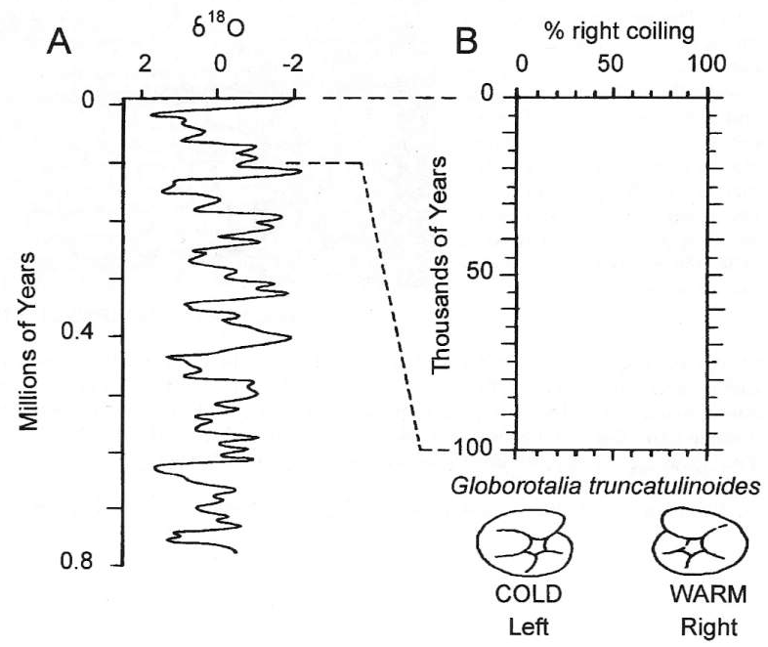
B
A

The curve in FIGURE A below shows an average record of δ¹⁸O for the last 800,000 years.
The curve is based on isotopic analyses of foram shells collected from deep sea sediment cores.

- Using a pencil, draw a straight line directly down from 0 on the δ¹⁸O record.
- Identify major warm (the negative values, going right) and cold (the positive values, going left) periods.
- Label the cool periods with a “C,” and the warm periods with a “W.”

- How many total major warm/cold cycles do you recognize? _______________________________
- Based on your answer, calculate the average duration of the warm/cold cycles.

Period = ___________________________________ thousand years

- Based on your answer above, what is the potential relationship between major warm/cold climate cycles and Milankovitch orbital cycles?

- How might an understanding of Milankovitch orbital cycles be used to predict FUTURE climate changes? Without people, what should Michigan be like 10,000 years from now?

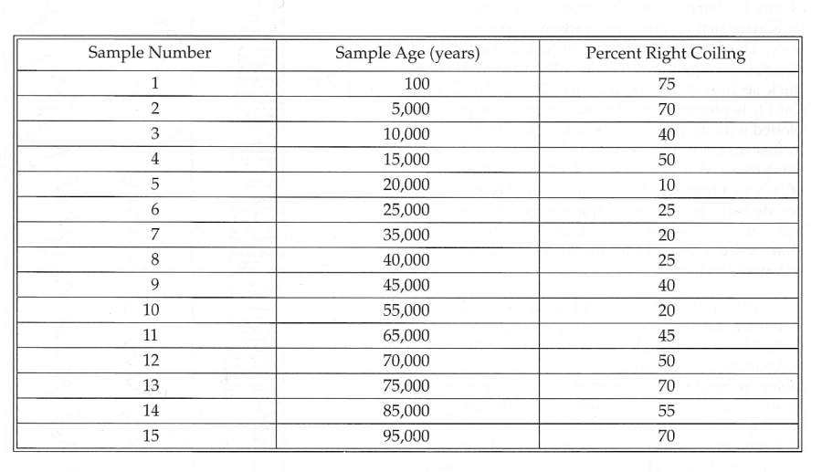
TABLE 1: Data on the sediment age and coiling direction of Globorotalia truncatulinoides from a mid-latitude deep sea core

- Plot the % right coiling against the sample age from the table on the right onto the δ¹⁸O curve in the table on the first page.

- Compare the oxygen isotope curve (δ¹⁸O) with the G. truncatulinoides coiling curve (remember that there is a difference in vertical scale between the curves). Do the two curves show relatively comparable climatic histories? Briefly explain your answer.

- Despite general cooling nearing the poles during periods of glaciations, the temperatures of ocean water in equatorial regions remained high throughout the Pleistocene. Briefly discuss the relative utility of isotopic analyses and shell coiling studies of deep-sea cores taken from near the equator for reconstructing paleoclimatic conditions.

