Directions: Describe the differences between the following features of the Earth between the Ice Age and the Present.
Feature | Modern | Ice Age
Sea Level | Higher than Ice Age | Much Lower than Modern
Average Planetary Albedo | Lower than Ice Age | Higher than Modern
Ice Sheets: Number, Size and Thickness | Only two ice sheets: Greenland and Antarctica. Smaller than Ice Age and shrinking. | Antarctica, Greenland, Lauentide Ice Sheet in Canada, Scandanavian Ice Sheet in West Europe, Barents-Kara Ice Sheet in Northern Asia, Patagonian Ice Sheet in S. America  6 total
Atmospheric Dust | Some human generated, but generally lower than Ice Ages | Higher than Modern due to cold, dry weather and more continent exposed to the atmosphere
Average Ocean Temperature | Higher than Ice Age and rising | Lower than Modern
Sea Ice | Reduced size and scale. Predicted loss during summer in 2040 | Extensive compared to modern.
Ocean Acidity | Higher due to dissolution of CO2 into the ocean water (lower pH value) | Lower acidity than modern (higher pH value)

What is the current pH of the ocean? 8.07 should be about 8.18
Global Warming Venn Diagram
Directions: Answer the question below using the Venn Diagram to record what people on both sides of the global warming debate say about human responsibility for this issue. Be sure to note specific facts that support the different perspectives.
Question: Has human activity caused the world’s climate to change over the past 100 years?
This exercise is based upon a debate between Bill Nye and Marc Morano found at: https://www.youtube.com/watch?v=gWT-EWKIR3M
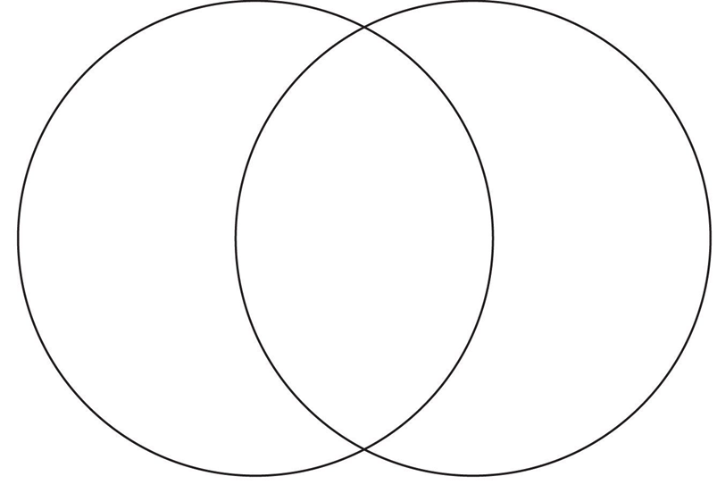
Those that say Yes feel this way because….
Those that say No feel this way because….
Both agree that…

